Hi Mike,
Some info to add concernant ETX80 and DSLR Nikon D3100.With my eyepiece adaptor + T ring the camera is unable to focus nowhere without eyepiece, placed on eyepiece port. Like I mention before the way to do it work is to engage the internal barlow.FOV in that case will be 0.4 degree, not too much. For Sun and Moon is ok, but for Mars, Venus, Mercury and deep space pictures is not enough. For the planets you need less, for deep space you need more FOV. After a lot of experiments I find one old microscope eyepiece to work just fine in my eyepiece adaptor and now the camera is able to focus very well without internal barlow engaged. In that way I gained 1.6 degree (decimal) – sufficient for deep sky photos. This eyepiece have two lenses, probably is plossl or kellner, and they are very low in the barrel-good for achieve focus. On ETX-80.For less FOV I use barlows. Here the picture:
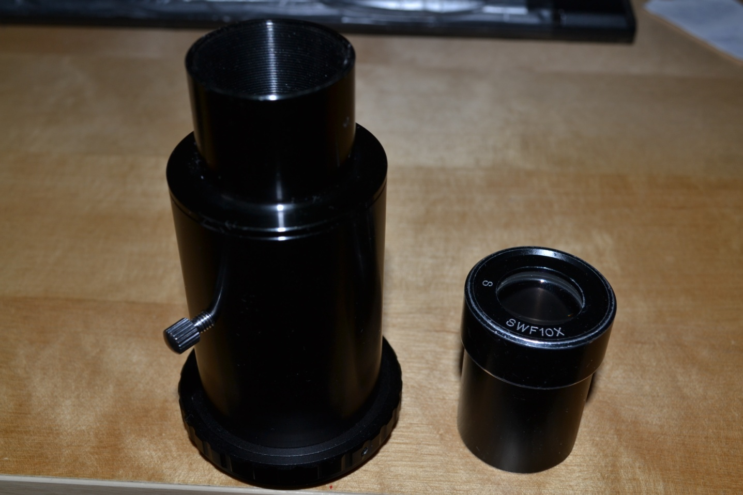

I also fabricated one piggyback adaptor for my two cameras D3100 and A560.All the pieces I buy from local supply chain RONA, equivalent to Home Depot in USA. This cost me not more than 30 dollars and 2 hours of work for assembly. Here is the pictures:
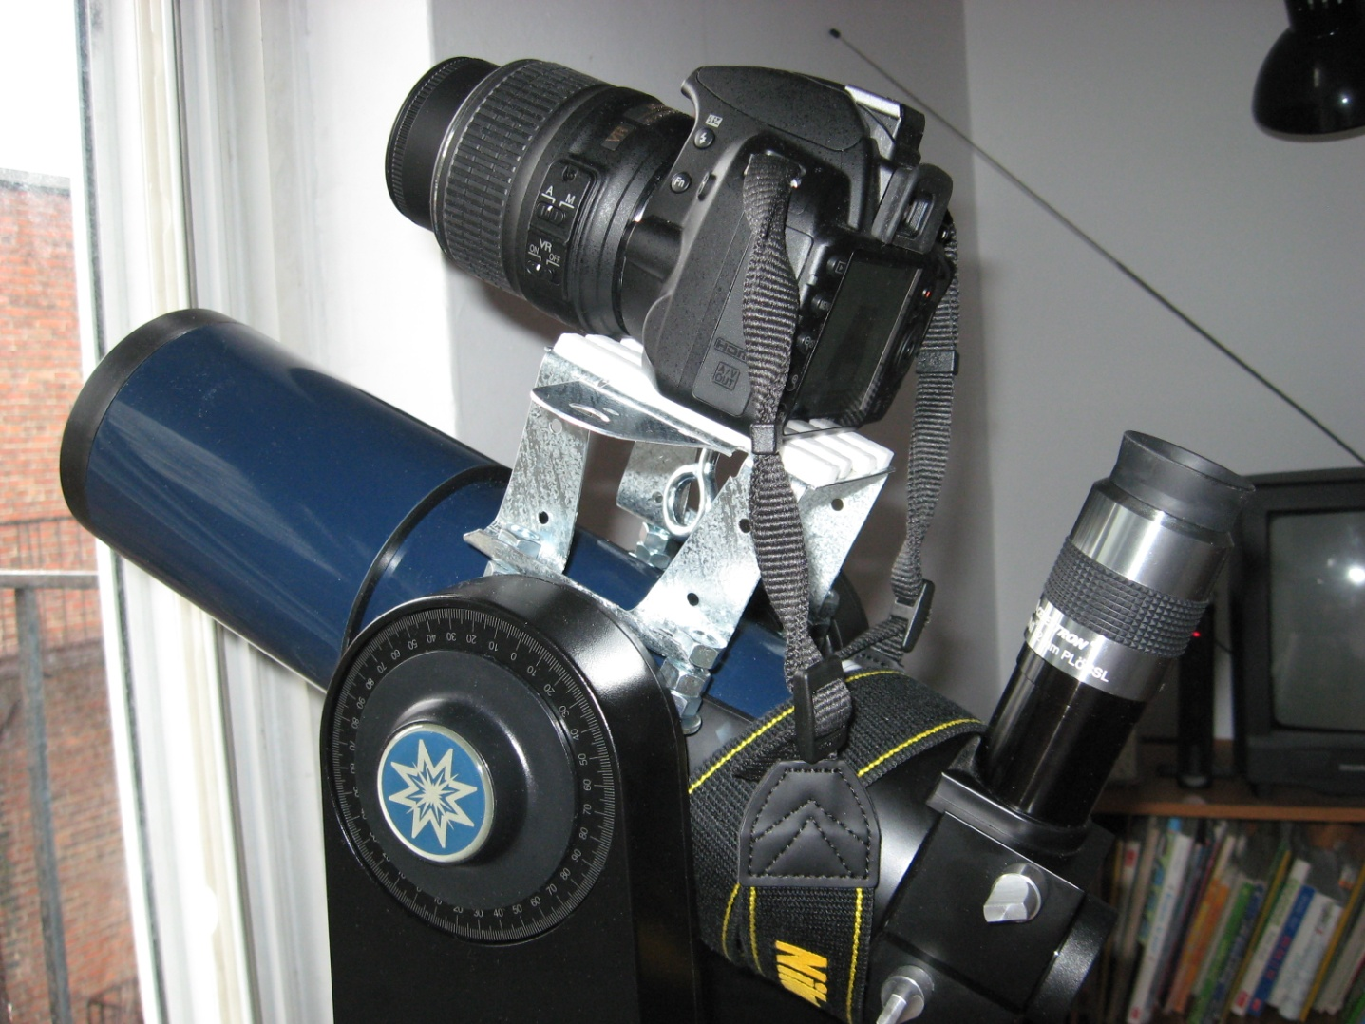
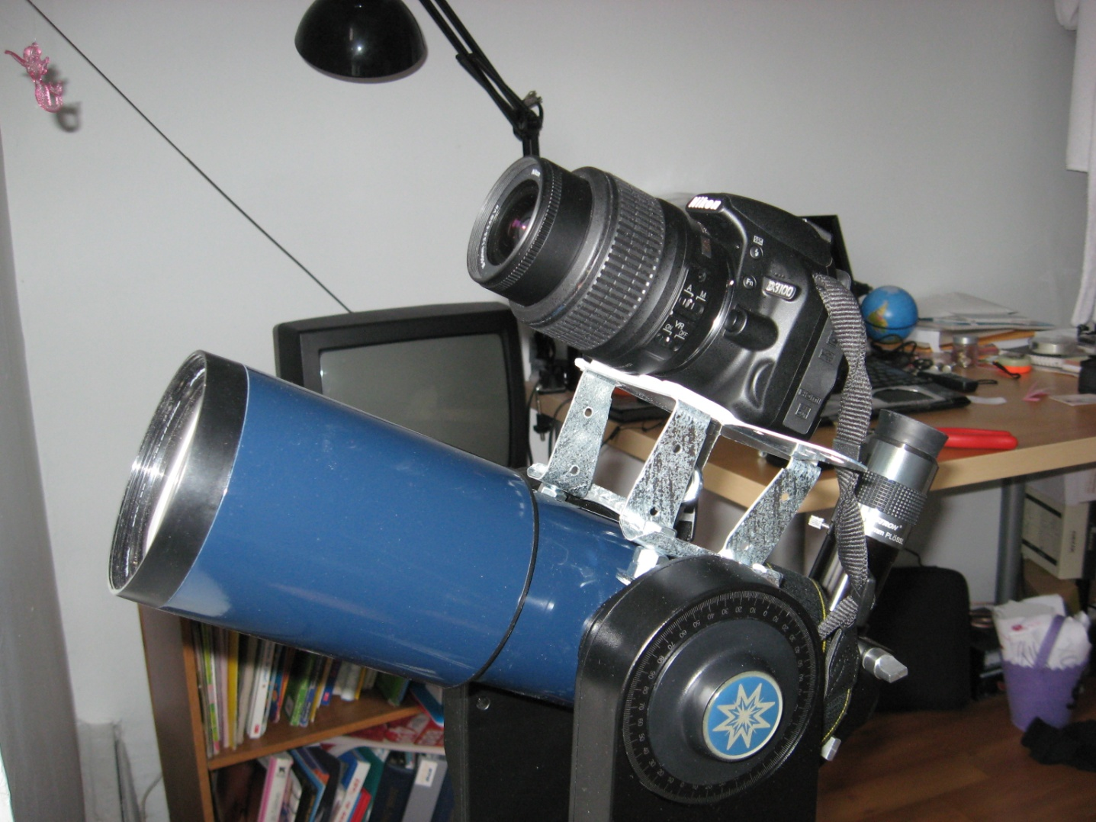
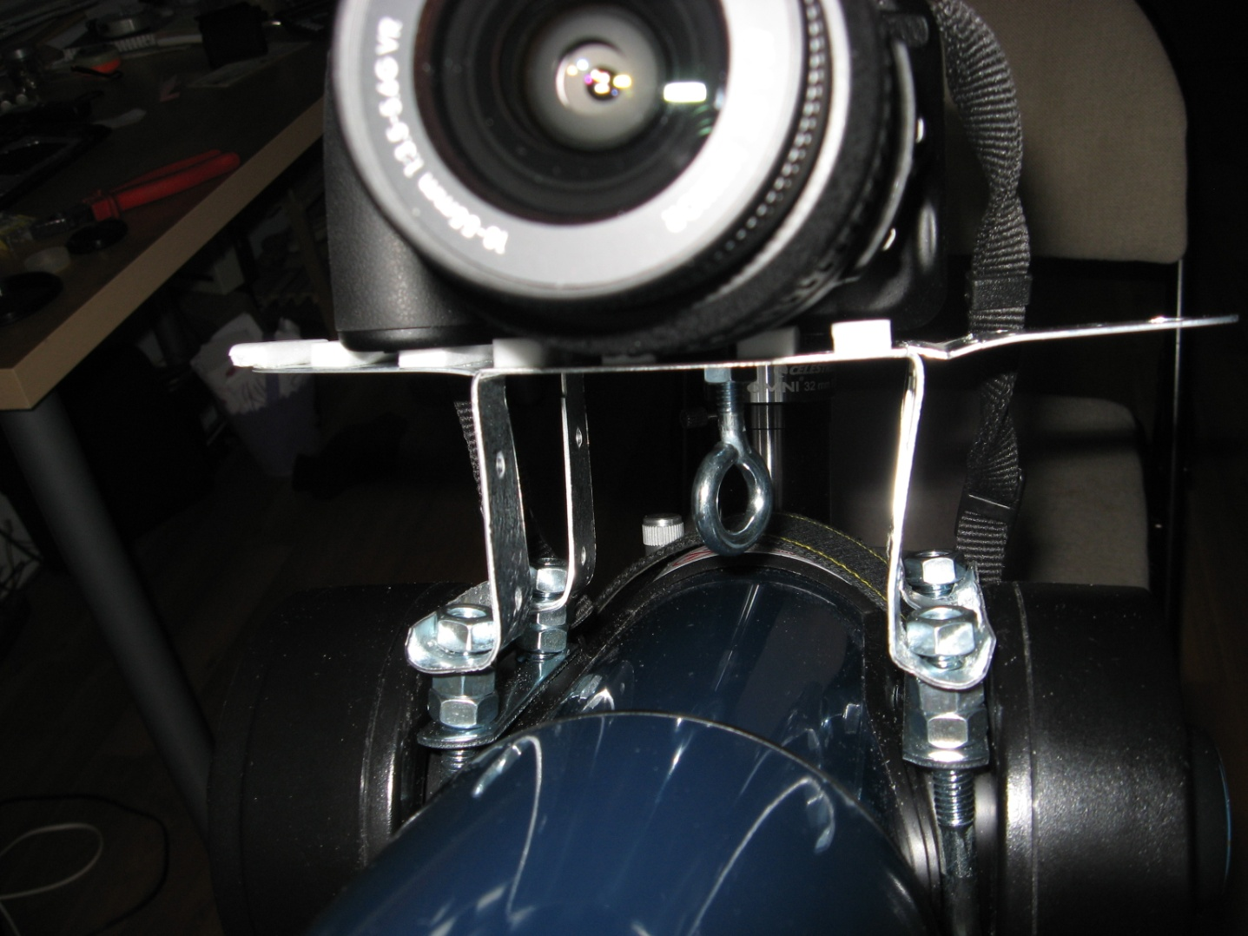
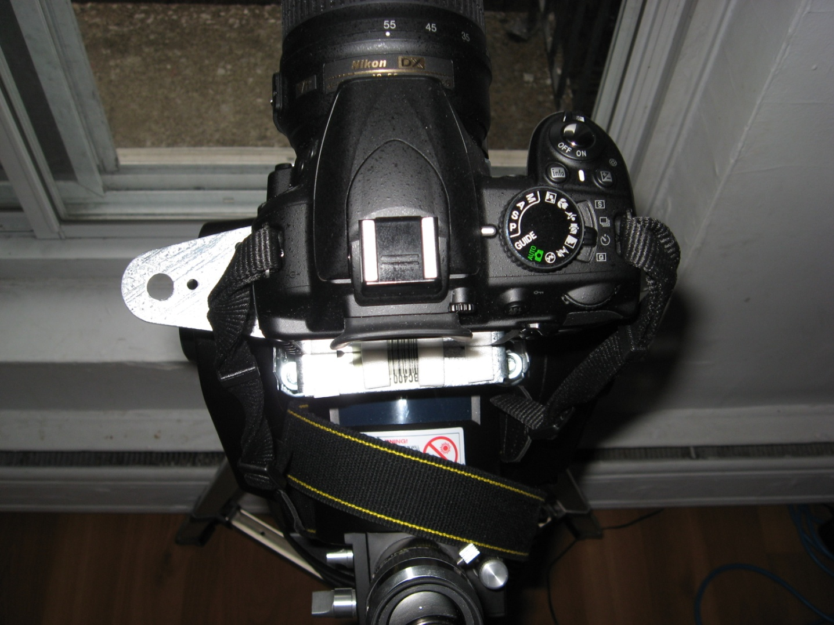
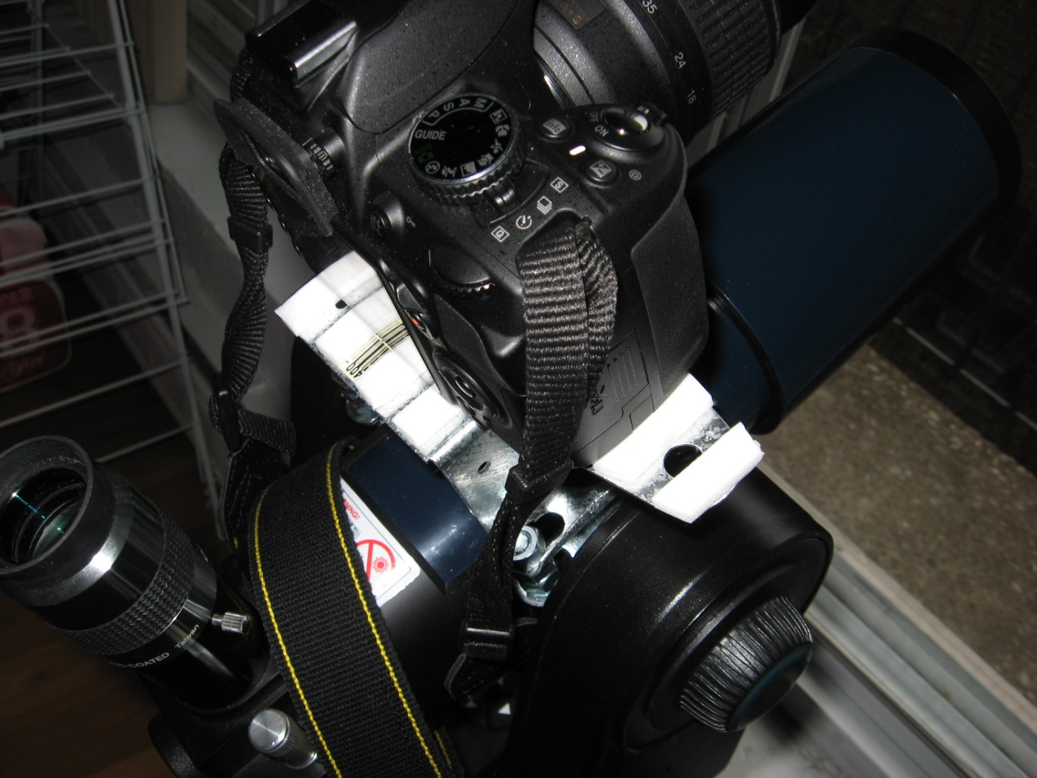
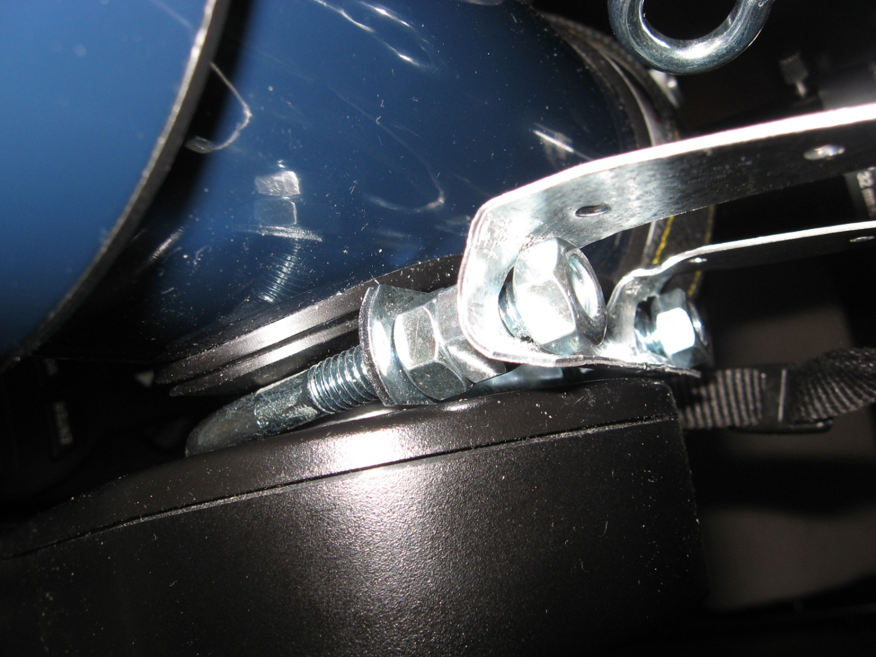
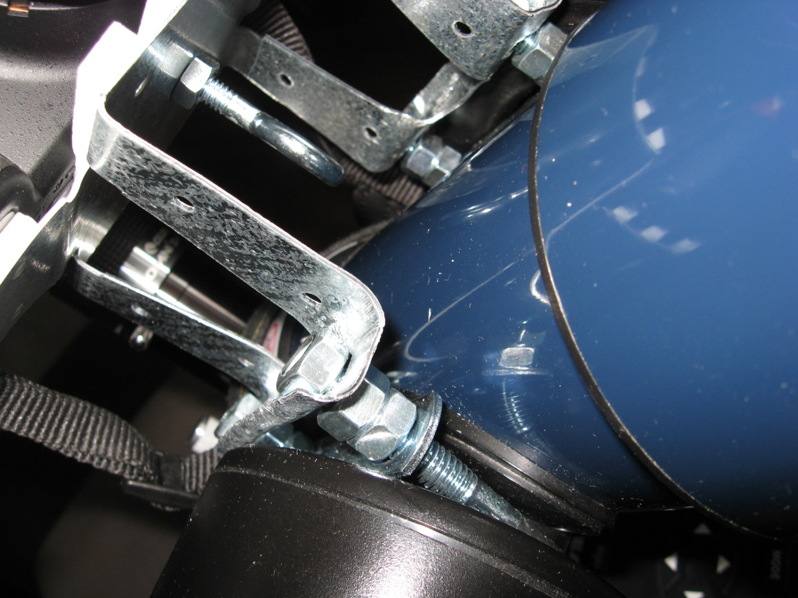
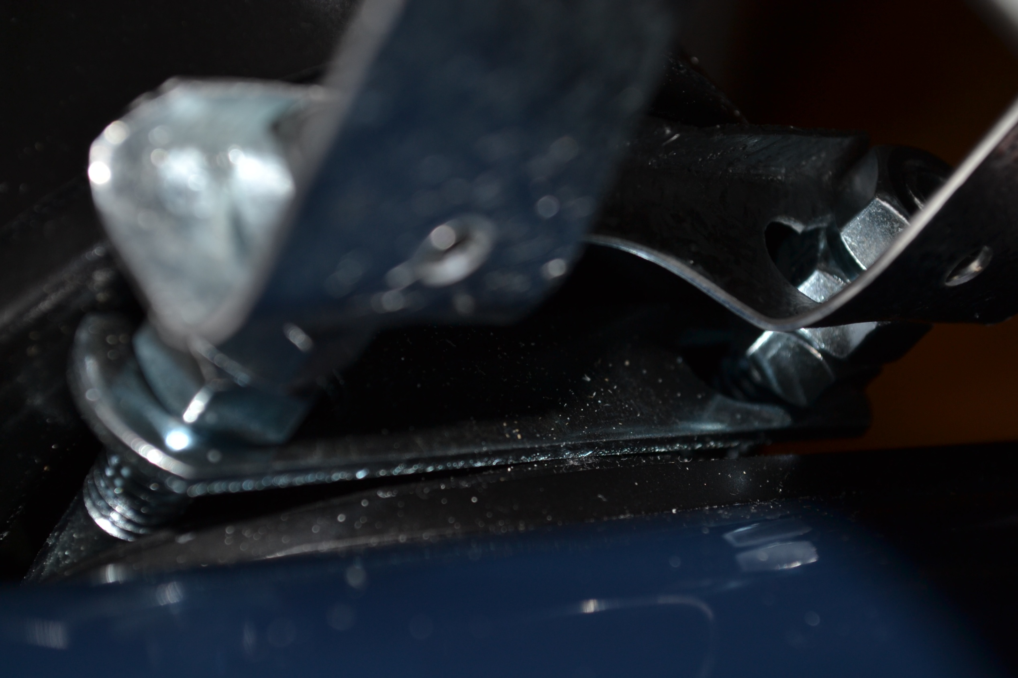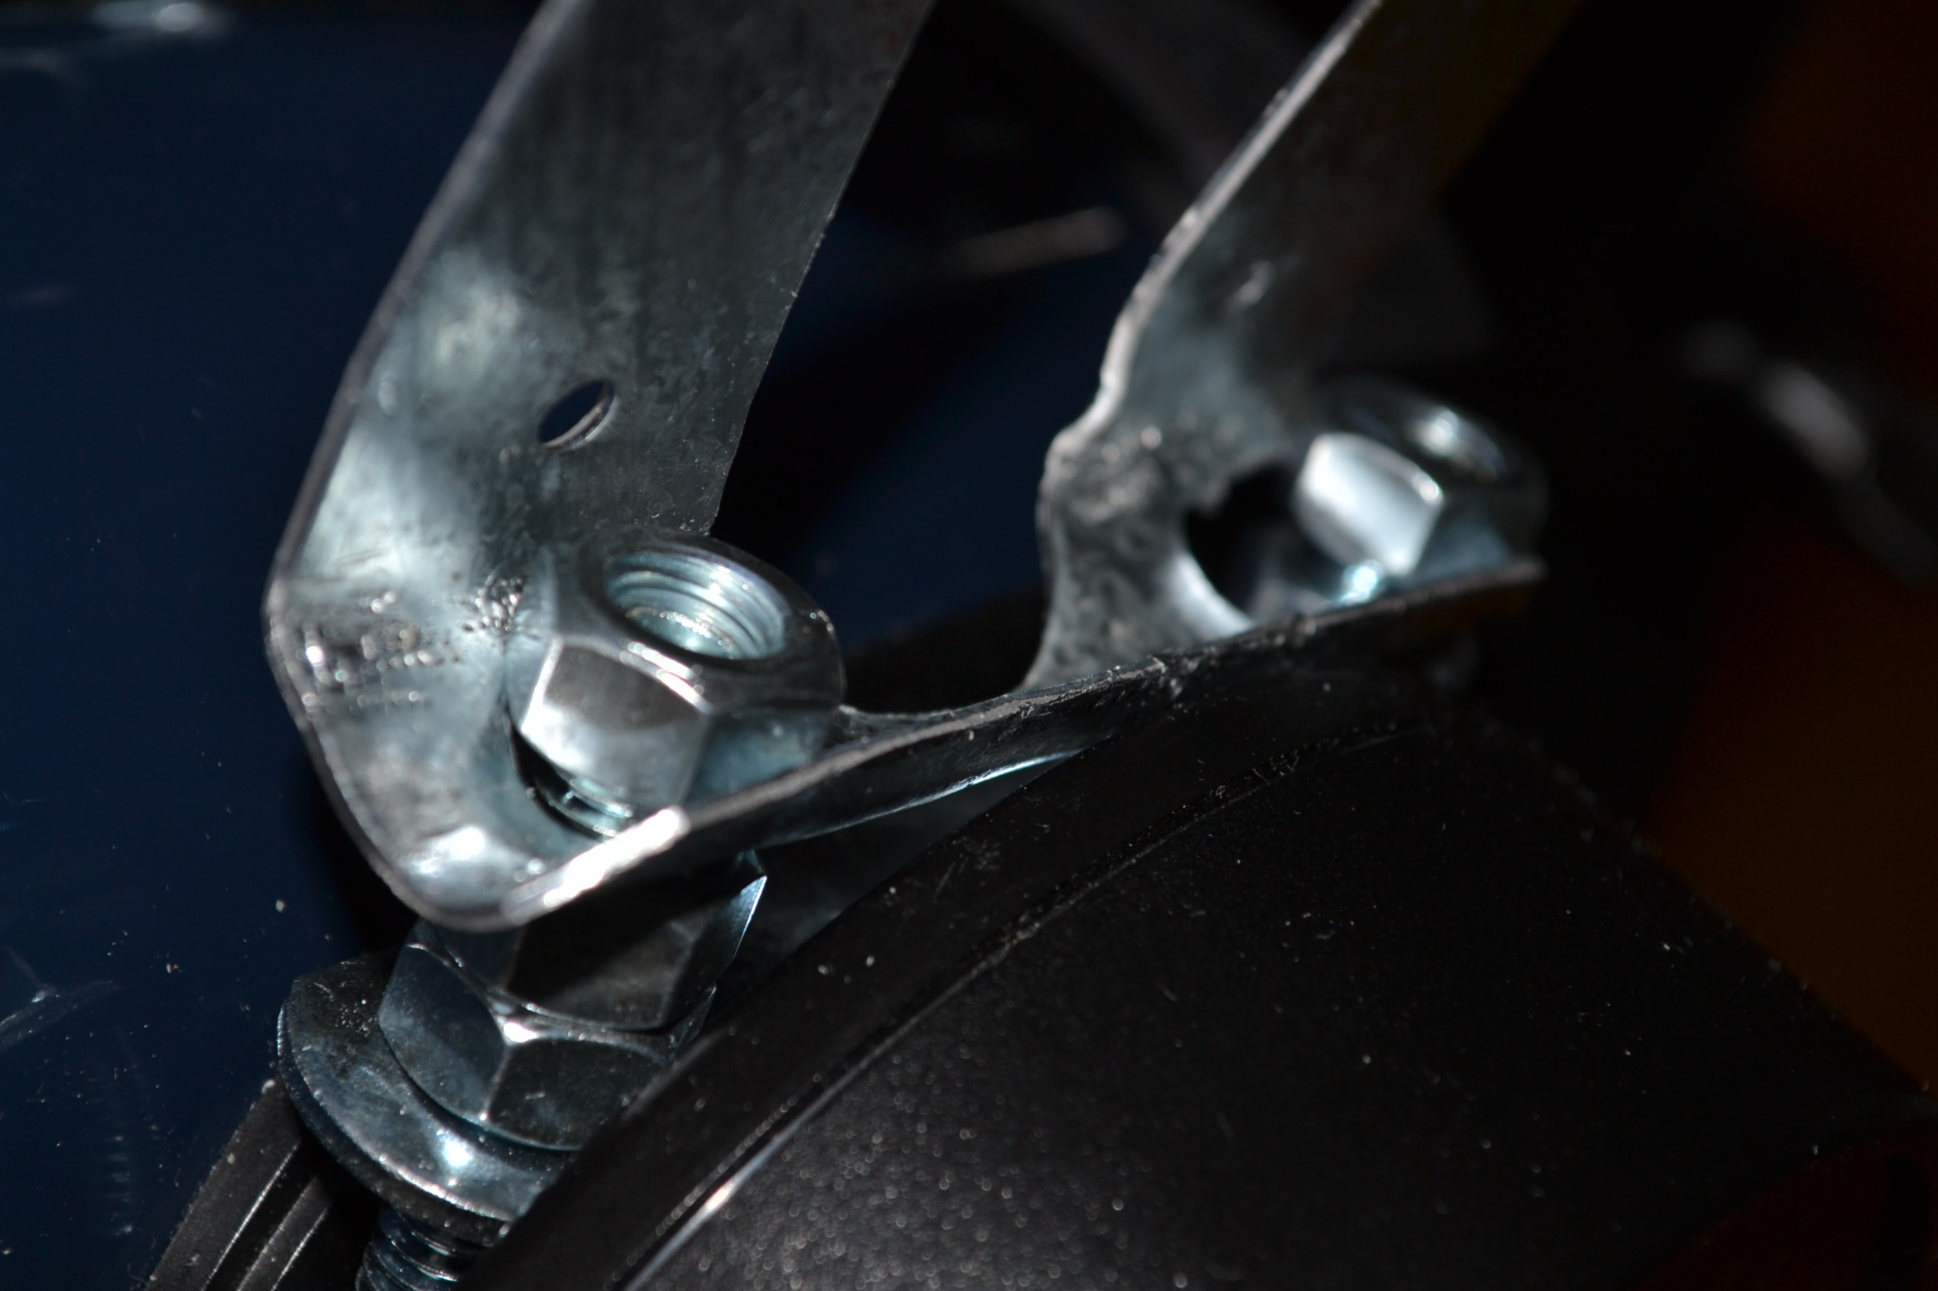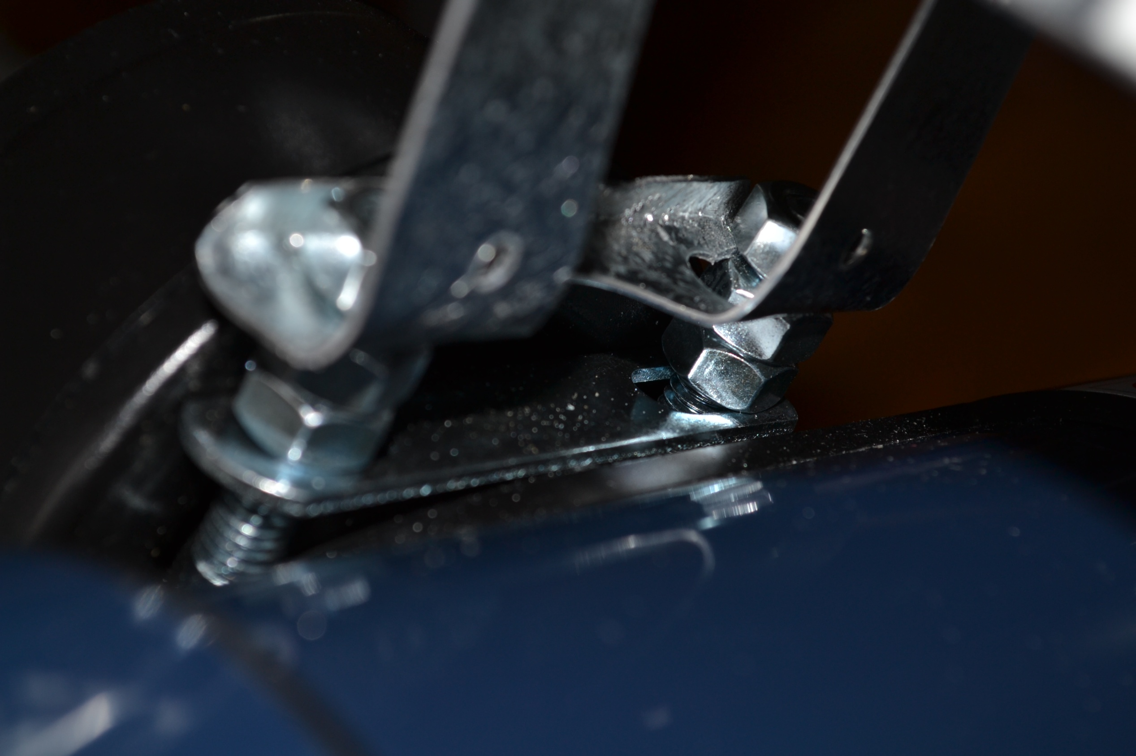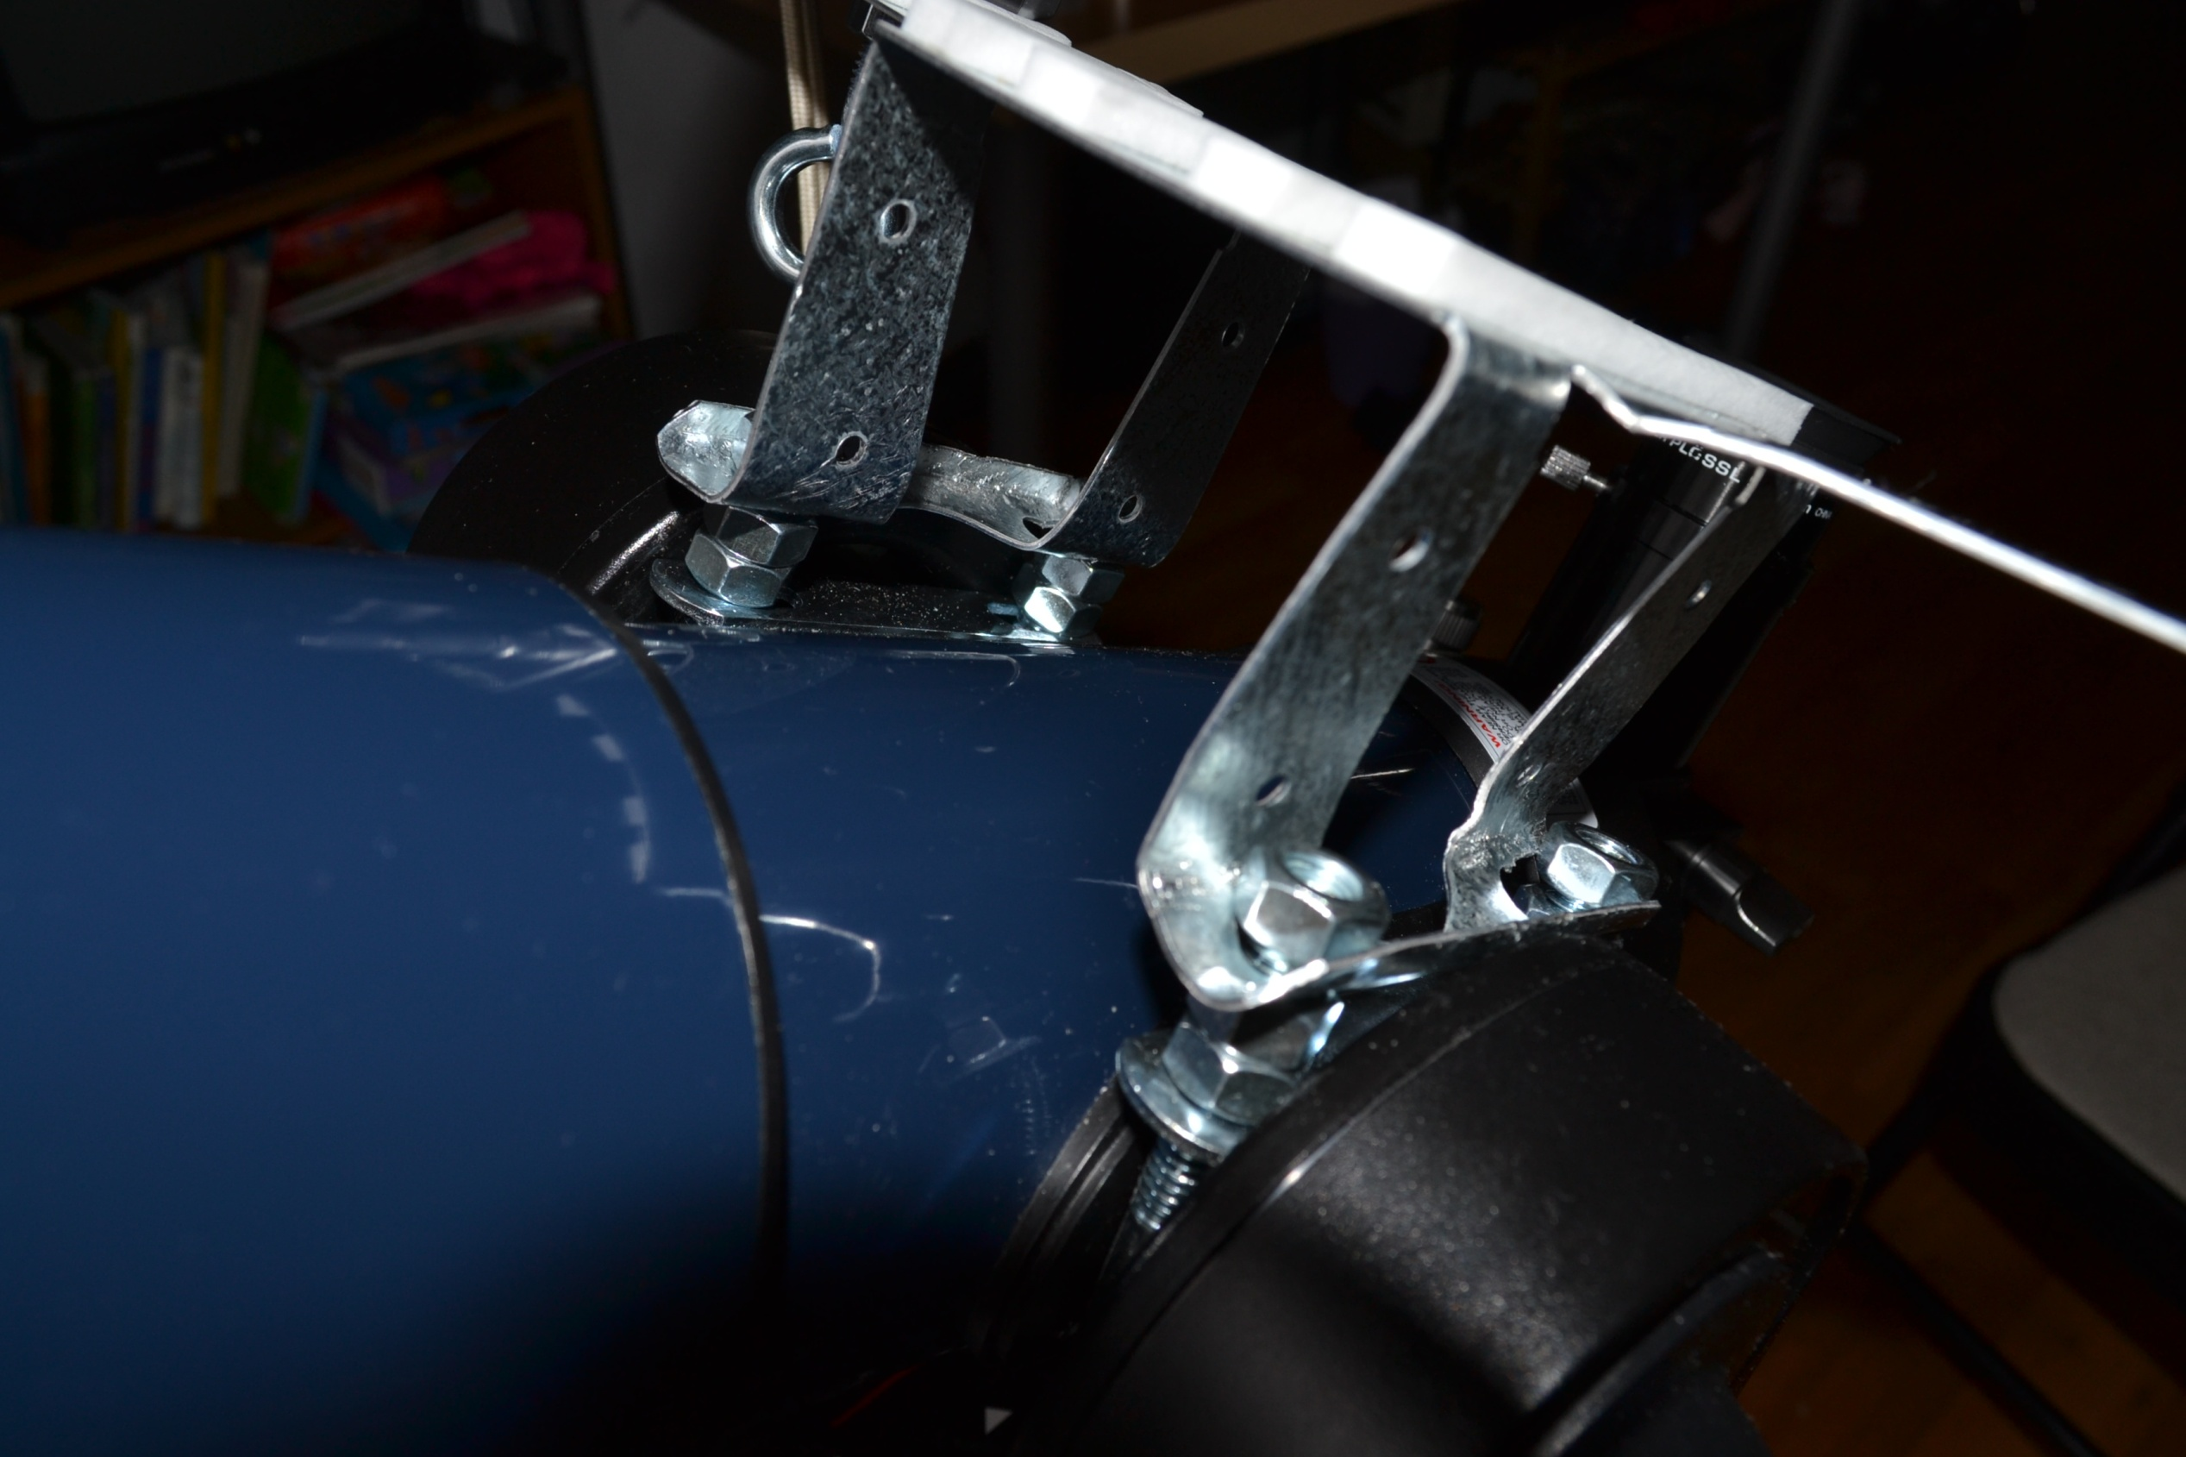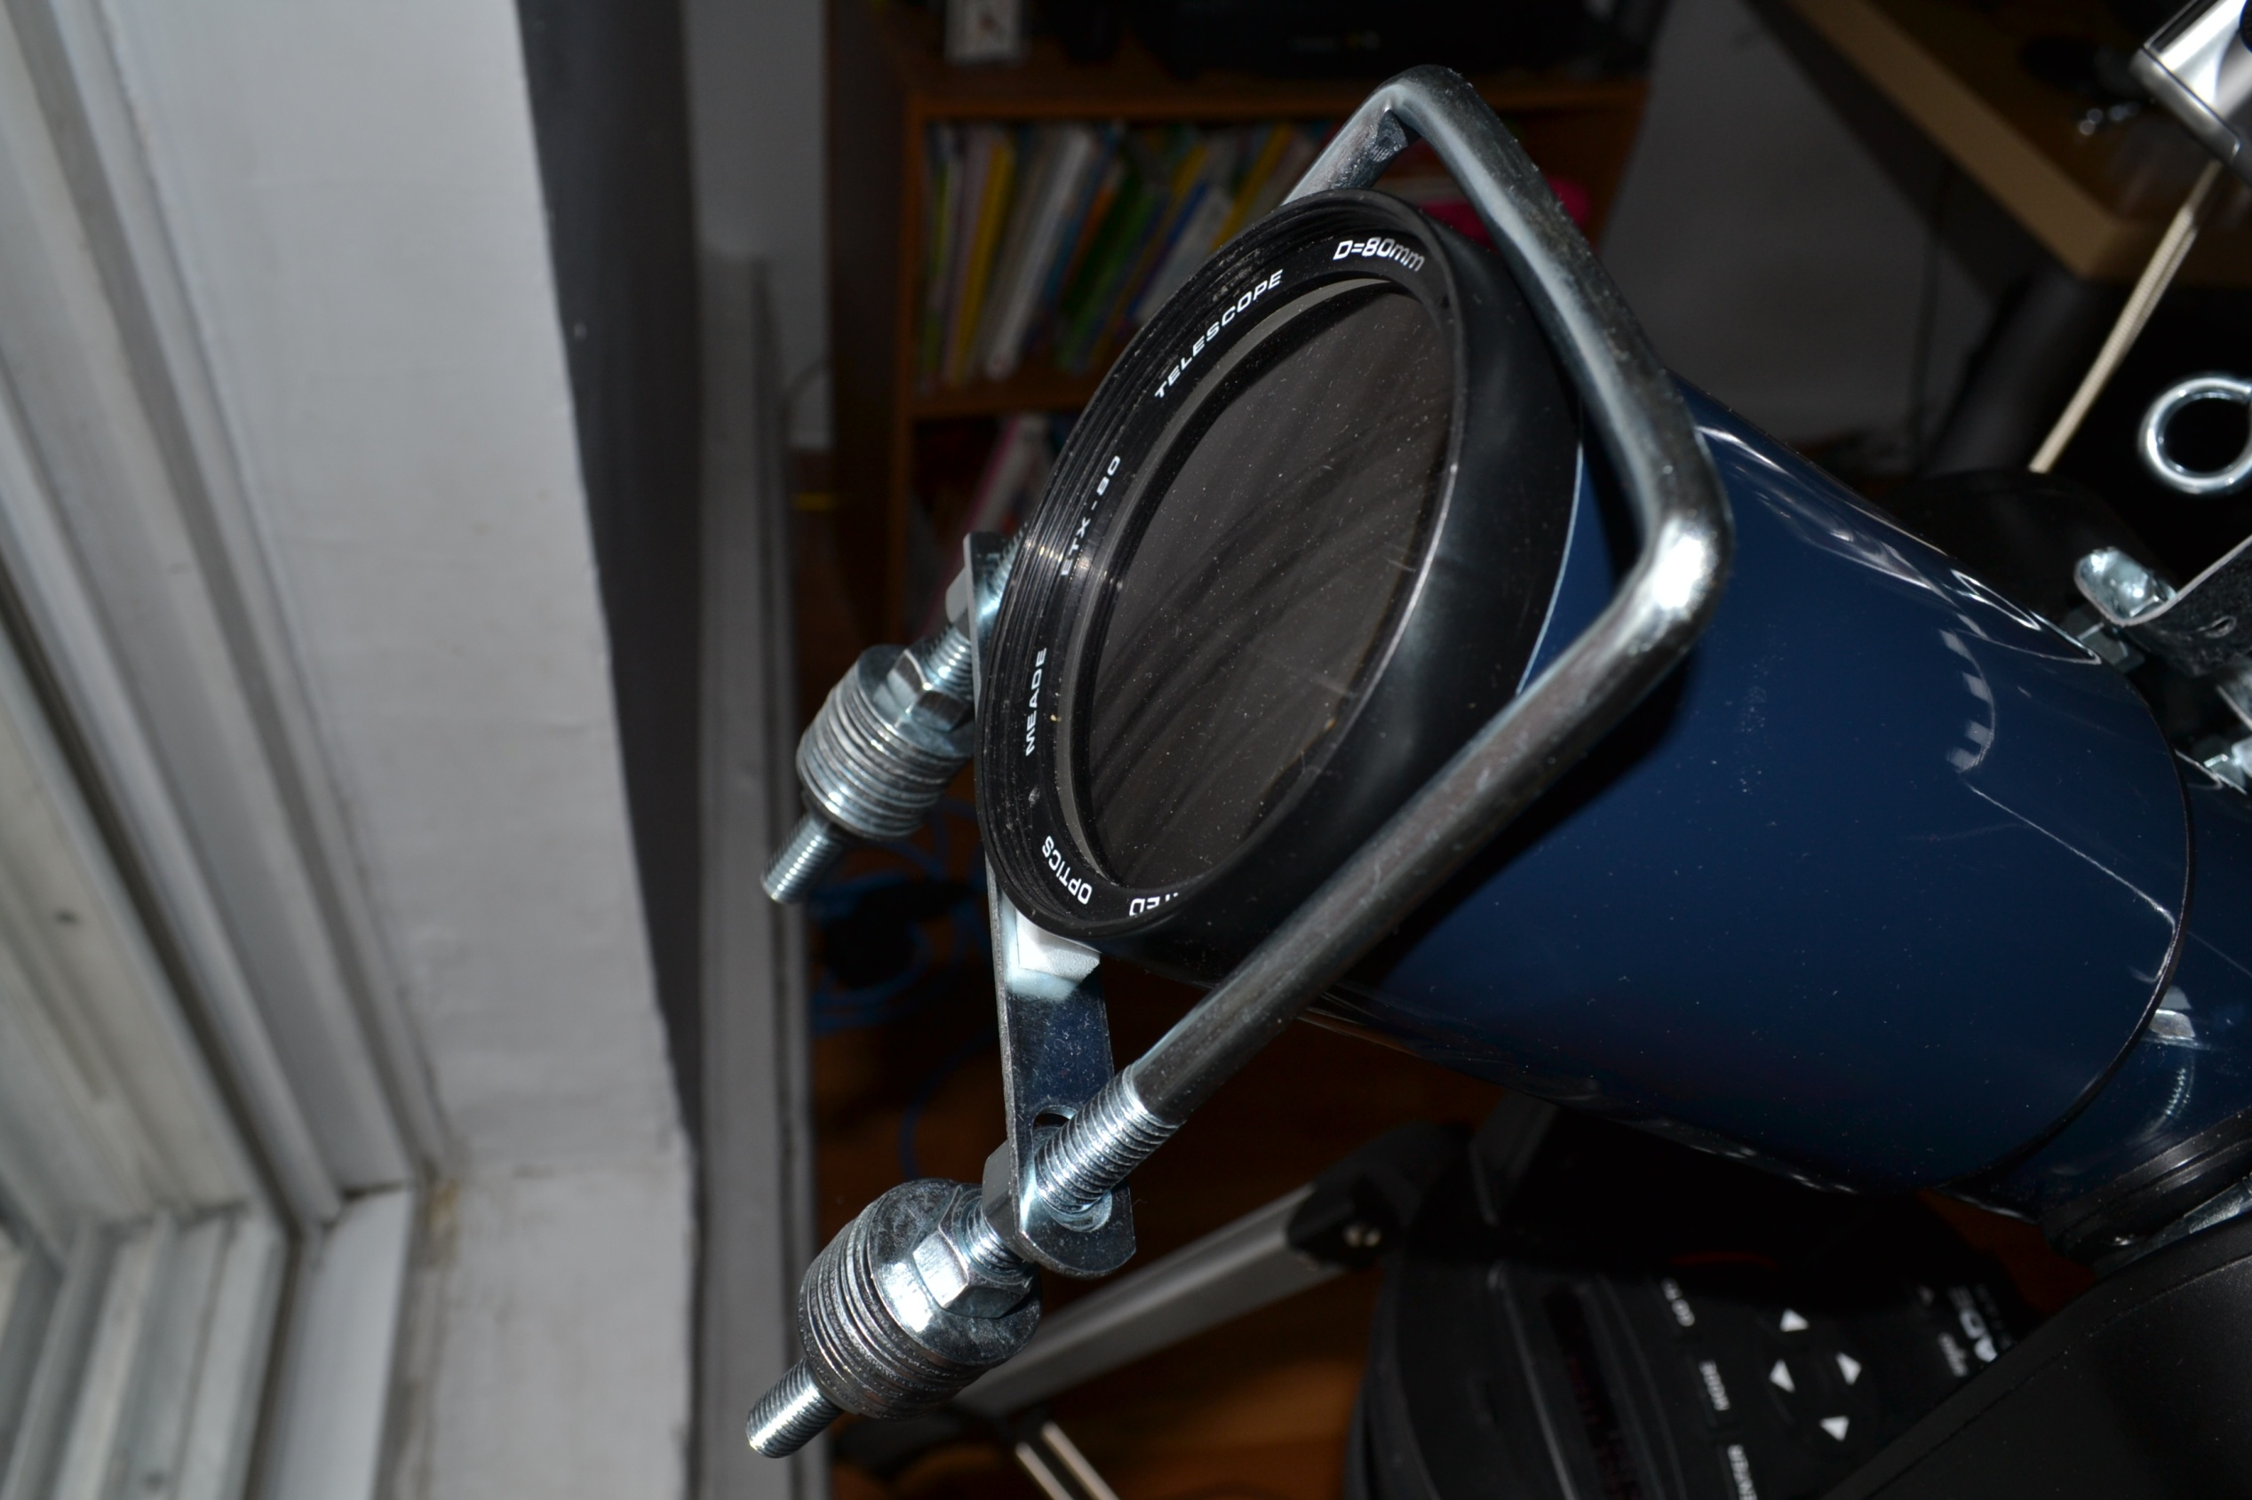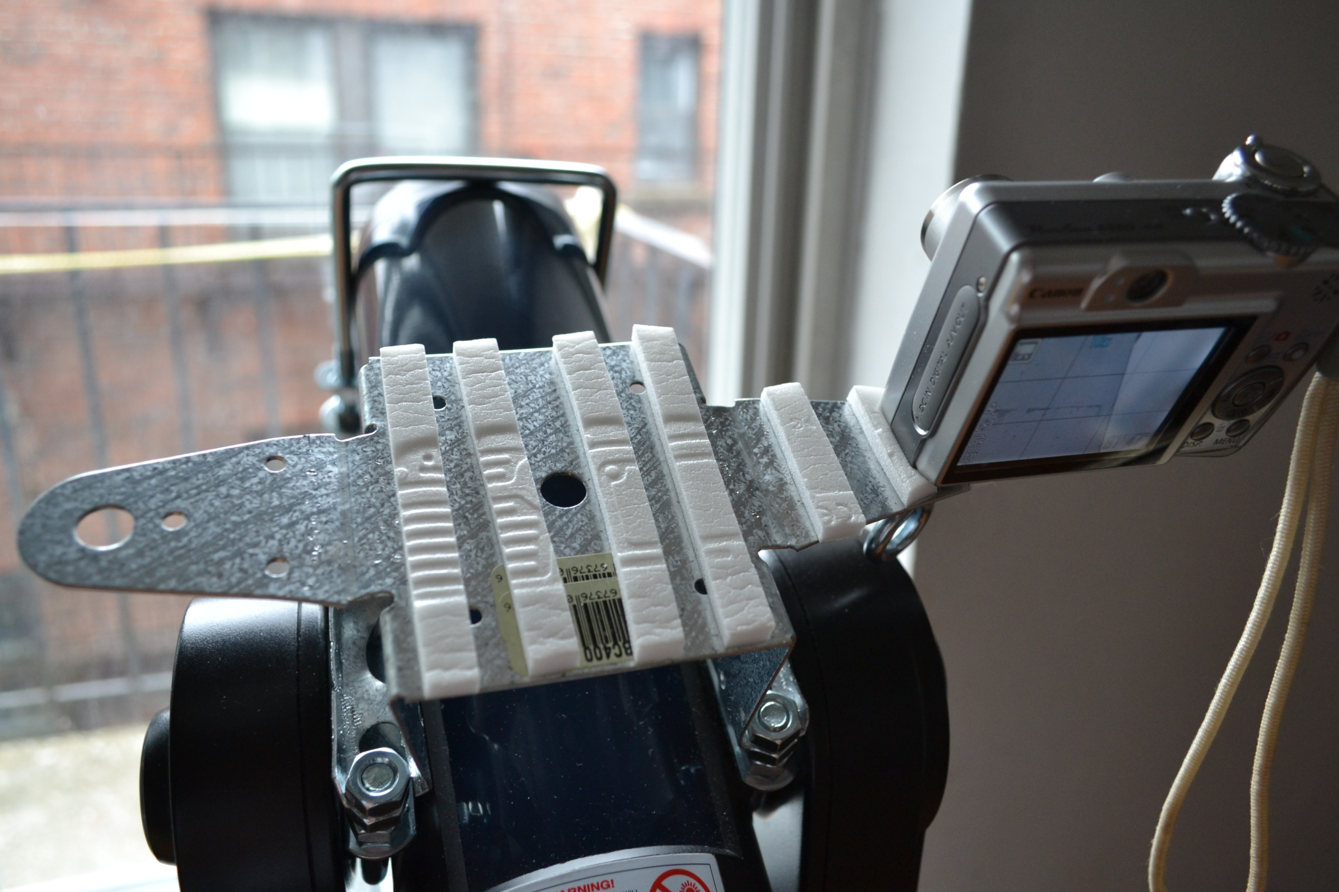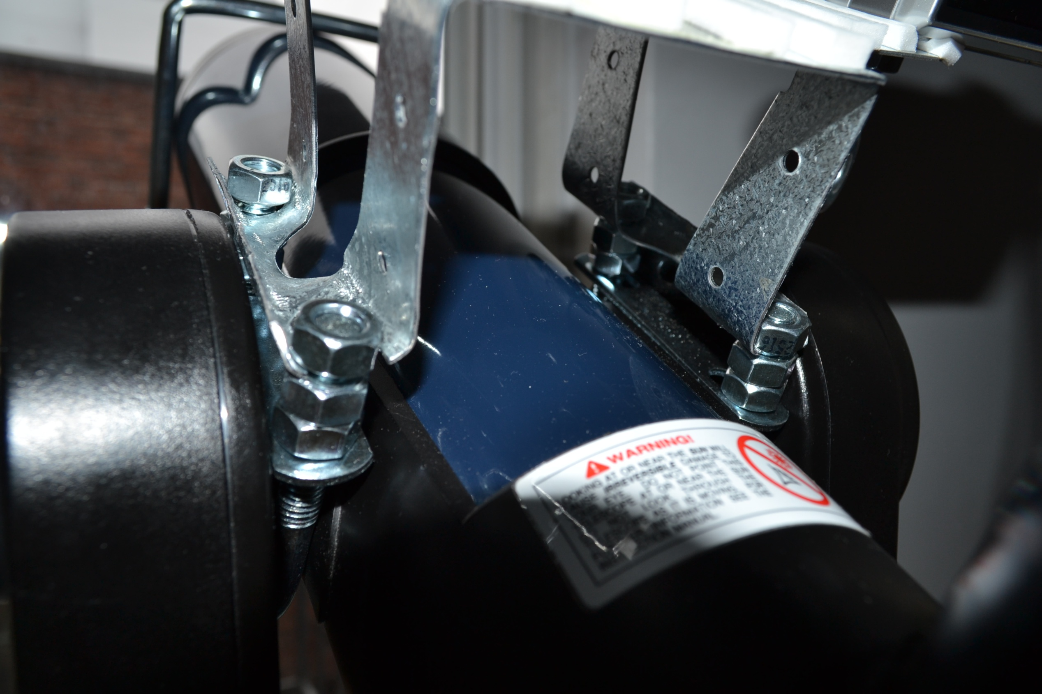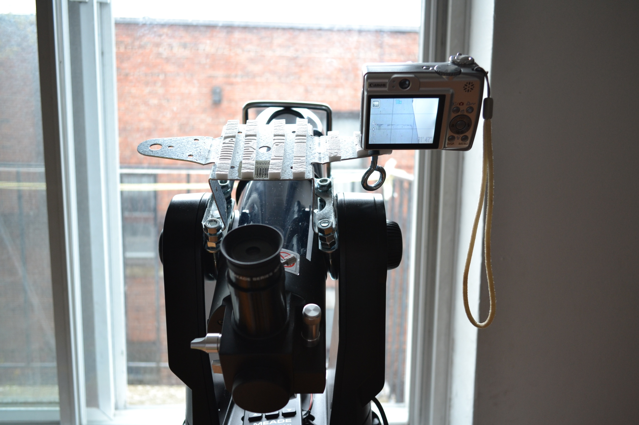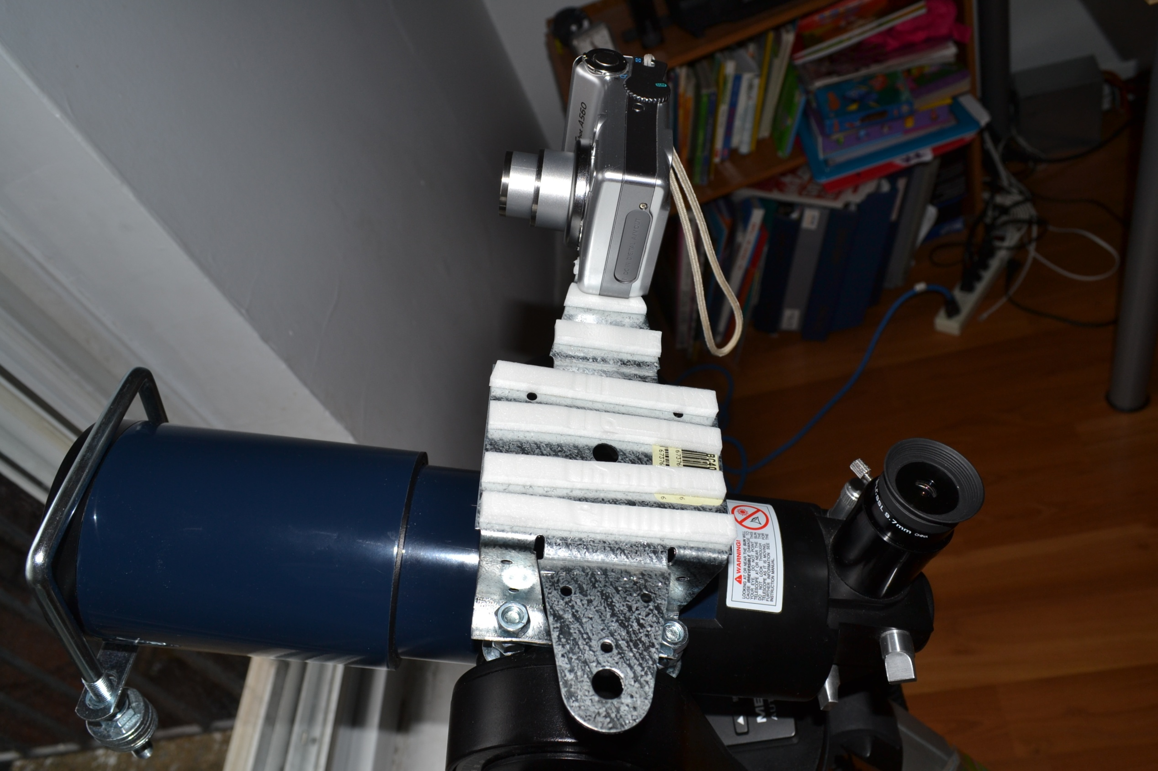
The two cameras fit at the same time on this adaptor.ETX-80 work just fine. Generally speaking this cheap plastic GOTO construction isn’t precise, but for the large FOV on the cameras this doesn’t matter. If you need balancing here is my cheap balance adaptor too. Enjoy and clear sky!
George - LZ3GT,VE2BUA,jbd30@abv.bg - Montreal, Canada

